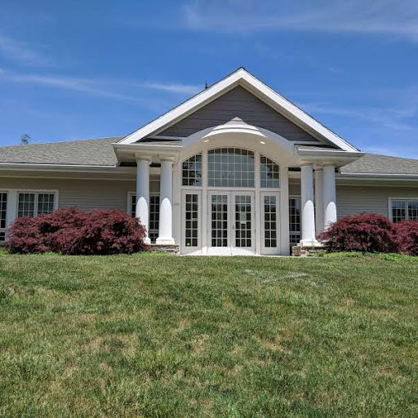
DALLAS TOWNSHIP BOARD OF SUPERVISORS
K. Gary Kirk, CPA Secretary/Treasurer
105 Lieutenant Michael Cleary Drive
Dallas, Pennsylvania 18612
Telephone: 570-674-2000
Fax: 570-674-3827
gkirk@dallastwp.org

NOTICE TO BIDDERS
Dallas Township Board of Supervisors invites bids for Pear Tree Lane-Misc. Repairs & Wearing Course Overlay. Bids will be received until 2:00 pm on Thursday June 20, 2019 at the Dallas Township Administration Building located at 105 Lt. Michael Cleary Dr. Dallas, PA 18612 (570) 674-2000 and read aloud at a special meeting of the Dallas Township Board of Supervisors at 3:30 pm on Thursday June 20, 2019 at the Dallas Township Administration Building. Copies of the documents may be obtained by Prime Bidders and Sub-Bidders at the office of Douglas F. Trumbower & Associates, Inc. located at 53 Gravel St. Wilkes-Barre, PA 18705 (570) 287-3178 for a non-refundable fee of $50.00. Documents may be examined between the hours of 9 a.m. and 4 p.m., Monday thru Friday at the office of Douglas F. Trumbower & Associates, Inc. A Bid Bond made payable to the Owner, in the amount of 10% of the Base Bid shall accompany each bid. Bonding companies for Bid, Performance and Payment Bonds must be listed in the U. S. Treasury Circular # 570. If the bid is accepted, the successful bidder(s) shall execute the Contract and shall furnish and pay for Performance and Payment Bonds in the amount of 100% of the Contract Price within 10 business days after receipt of the Notice of Award from the Architect along with the required Certificates of Insurance. This project shall comply with the Pennsylvania Prevailing Wage Act, including labor standards, prevailing wage determination decision, and anti-kickback regulations which are included in the contract documents of this project and govern all work under the contract. All bids shall remain irrevocable for sixty (60) calendar days after the actual date of the opening thereof. Dallas Township Board of Supervisors reserves the right to reject any or all bids and to waive any informality in the bidding.

